Introduction to the Points Based Activation System for Workforce Australia webinar

# Slide 1 - Introduction

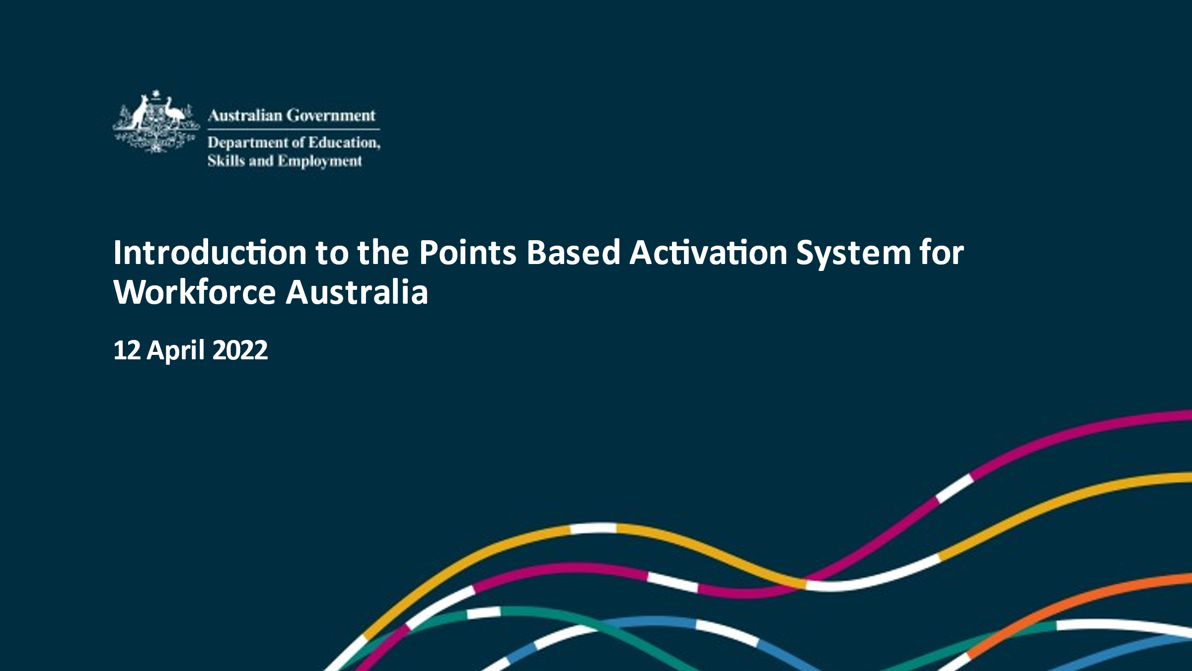

Good afternoon all and thank you for taking the time to be here with us today.

My name is Melissa Ryan, I am the First Assistant Secretary for the New Employment Services Model Division. Also with me today is Kellie Spence, Assistant Secretary of the Digital Services Branch, and members of the team with responsibility for the design and implementation of the Points Based Activation System, or PBAS.

PBAS is the new and flexible approach to job seeker activation that provides individuals with choice and flexibility around the way they manage and meet their mutual obligation requirements in return for their income support.

Under PBAS, job seekers are encouraged to actively engage and participate in tasks and activities on their pathway to employment and are rewarded through earning points to meet a points target.

This presentation will outline the objectives of PBAS, and the evidence that informed the development and design of the PBAS framework. It will also detail each element of the PBAS framework and demonstrate how job seekers will use PBAS to meet their mutual obligation requirements, and provide an overview of the role and responsibilities of the provider and the Digital Services Contact Centre, or DSCC, to support job seekers using PBAS in the Workforce Australia model.

We are happy to take questions. If I could ask that you please type in any questions and we will answer them at the end of this presentation.

# Slide 2 – Acknowledgement of country



Firstly, I would like to provide an Acknowledgement of Country.

We respectfully acknowledge the traditional owners and custodians of country throughout Australia and their continuing connection to land, waters and community.

We pay our respects to them and their cultures, and Elders past, present and emerging and we wish to extend those respects to those who are present with us today.

# Slide 3 – Why introduce a points-based system?

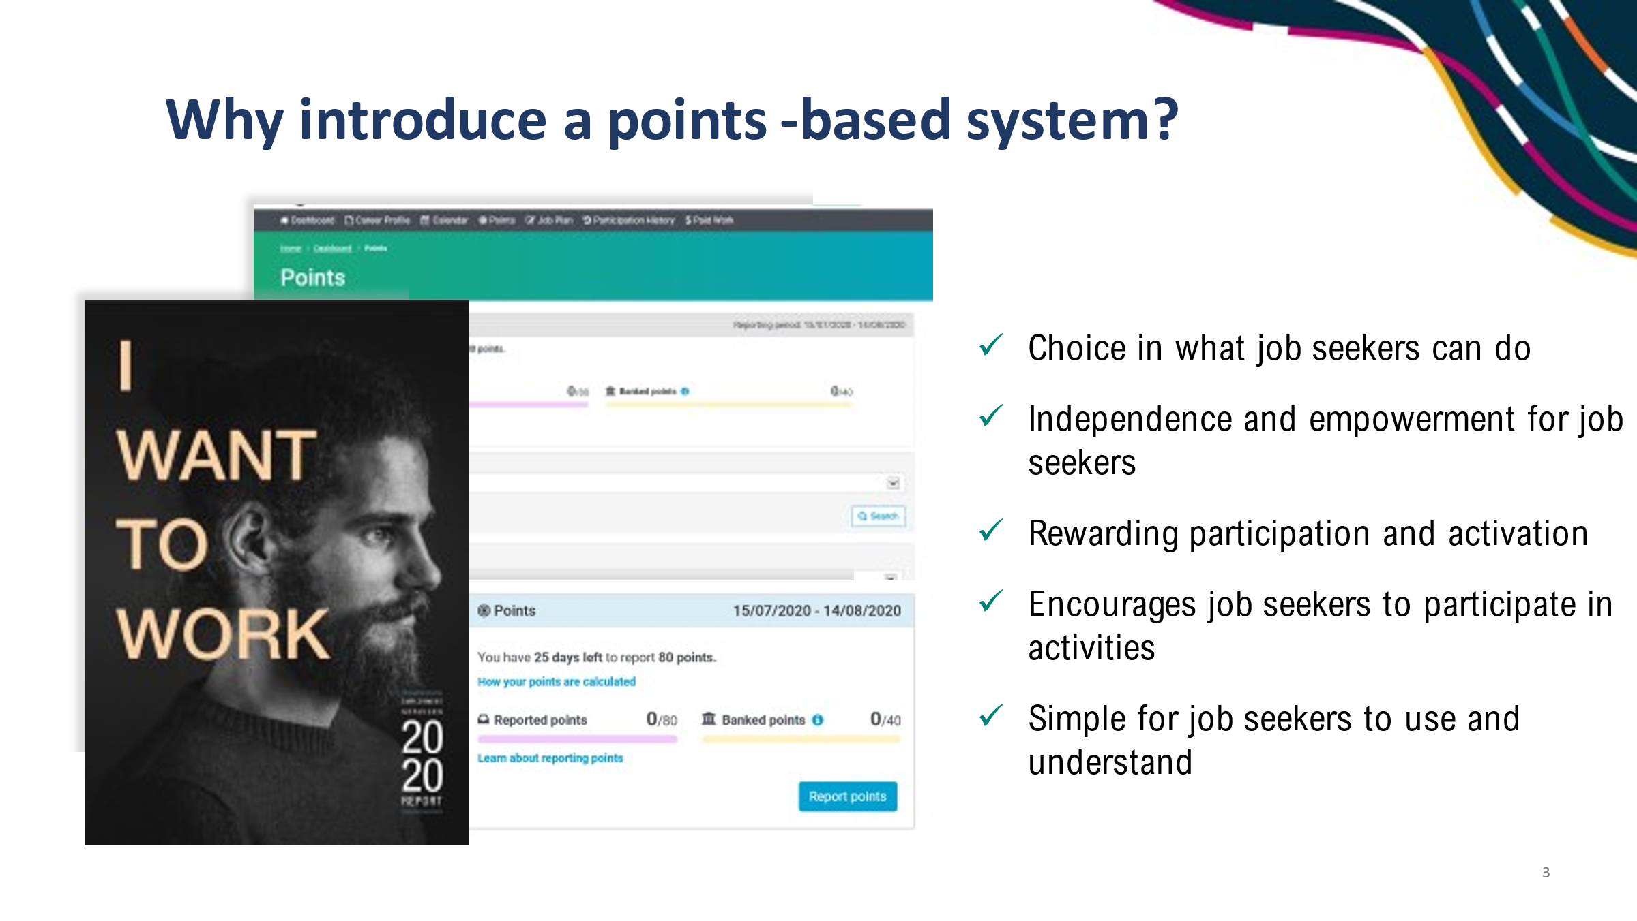

Firstly, I would like to briefly explain why we are introducing a points-based activation system.

An Employment Services Expert Advisory Panel were appointed in January 2018 to help shape the future design of employment services in Australia. The panel recommended a flexible activation framework and points based mutual obligations approach whereby mutual obligations can be met in different ways.

The panel recognised that there is no one size fits all approach to getting people into employment.

That job seekers should have flexibility to determine the tasks and activities that they can undertake to move towards employment and keep off income support.

PBAS has been trialed in the Adelaide South and Mid North Coast employment regions since December 2020.

Initially, there was hesitation with using PBAS and a feeling that it was complicated. However, once trial providers and job seekers had a better understanding of how it operated, the feedback has been positive.

Elements they particularly liked were:

* + - the ability to choose what a job seeker can do to meet their requirements, rather than a set number of monthly job searches.
    - the independence and empowerment PBAS provides to job seekers and that it encourages them to do activities as they earn points for their participation.
    - PBAS is considered a good change in the way providers engage with job seekers by rewarding participation and activation rather than focusing on compliance.
    - PBAS is simple and not a difficult process to use.

There are elements to the trial version of PBAS which were constrained by our IT systems, such as the application of upfront activity credits. There was also extensive feedback provided during consultation around the points values for tasks and activities and the need for a minimum job search requirement.

This feedback and learnings from the trial have been used to inform the design and framework of PBAS for Workforce Australia.

# Slide 4 – PBAS Framework objectives

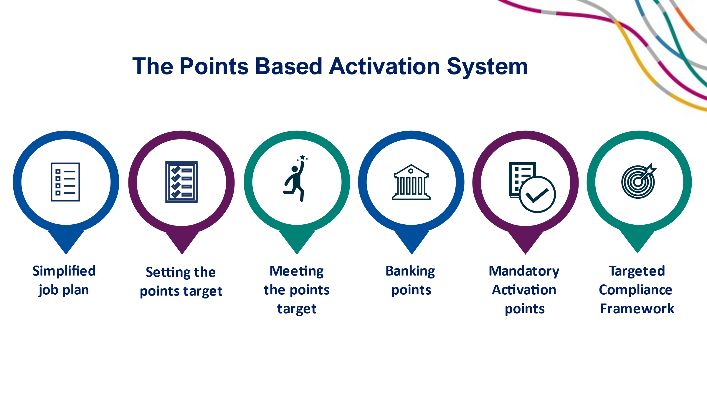

PBAS provides all job seekers, both self-managing in Online Services and those in Workforce Australia Services, with greater ownership of their pathway to employment and promotes personal responsibility.

While providing job seekers with flexibility and choice, the framework provides job seekers with support, and they can contact their provider or the DSCC to discuss their requirements or if their circumstances change at any stage.

The PBAS framework focuses on engagement and positive activation.

It focuses on what job seekers are engaging in or what they need to do to gain employment.

It encourages job seekers to connect to learning and training opportunities to build their skills, as well as access support services to overcome employment barriers.

The new activation approach represents a shift in how providers will engage with job seekers.

Providers will be expected to identify and promote a diverse range of tasks and activities tailored to the job seeker and local labour market.

I will now take you through the elements of the PBAS framework.

# Slide 5 – Simplified Job Plan

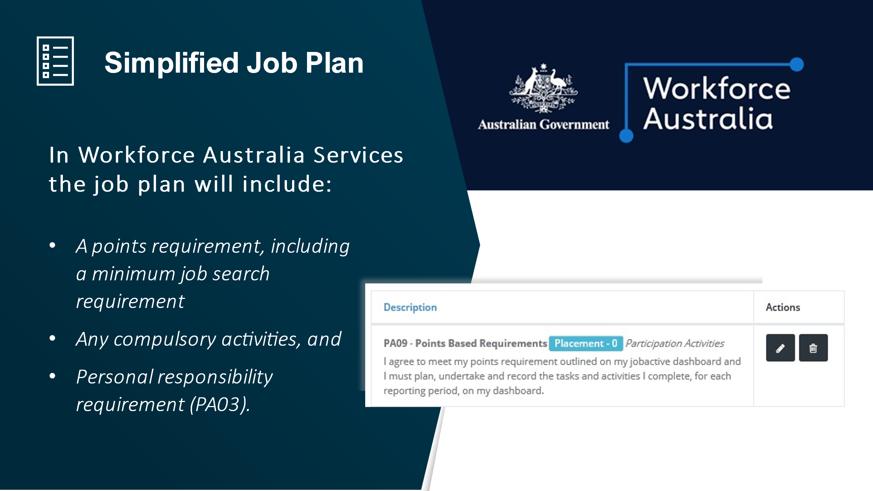

Firstly, job seekers in employment services must agree to a job plan.

The job plan has been simplified and focuses on compulsory obligations in return for receiving income support.

Currently, job plans include all compulsory and/or voluntary activities or other requirements the job seeker will undertake in order to meet their mutual obligation requirements.

In Workforce Australia, the job plan compulsory items include:

* the points requirement
* a minimum job search requirement
* to accept and retain suitable paid work
* action job referrals and opportunities
* attend job interviews, and
* attend any appointments notified as compulsory.

For job seekers in Workforce Australia Services, the requirement to accept personal responsibility to self-manage and accurately record participation efforts in PBAS will also be included in the job plan as compulsory but can be removed by the provider if it is not appropriate to the individual job seeker. For example, where the job seeker has been identified as lacking digital literacy skills and cannot self-report their own requirements.

Mandatory activities will only be added to the job plan at the activation points when a review has determined that the job seeker has not actively engaged (i.e. met the requirement early).

Streamlining the job plan will deliver significant flexibility for job seekers and reduce red tape and administrative burden for providers and the DSCC. Job seekers can easily vary their participation efforts to meet their points at any time by selecting different tasks and activities without needing to re-negotiate the job plan.

The job seeker can discuss the contents of the job plan with the provider or the DSCC to ensure they understand their mutual obligations requirements, including that they must use PBAS to meet their points target.

# Slide 6 – Setting and tailoring the points target

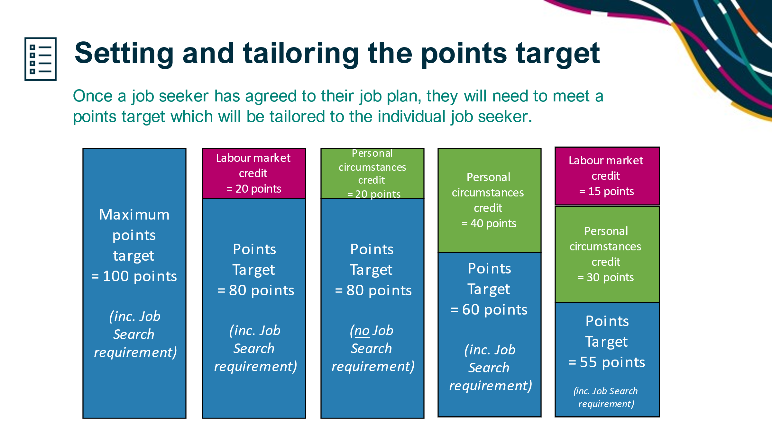

As part of creating the job plan, the provider must set a tailored points target for the job seeker that considers their local labour market conditions and their personal circumstances. Self-managing job seekers in Online Services can also have their points target tailored to their individual circumstances and can discuss this directly with the DSCC.

Providers and the DSCC will tailor the points target by applying a points credit to reduce the points target at the start of each reporting period, or at any time throughout a reporting period.

Job seekers will need to meet their tailored points target each monthly reporting period. If there are no adjustments made to the target by the provider or DSCC, job seekers have a maximum points target of **100 points** to meet each month.

In Workforce Australia, credits are not applied automatically. It is expected that each job seeker has their own, individually set points target that reflects their ability and personal circumstances.

As part of their points target, job seekers will generally need to complete a minimum job search requirement of five job searches each month. A job seeker will not be able to meet their points target without completing this requirement. Providers and the DSCC are expected to consider the minimum job search requirement when setting the points target, and can adjust the minimum job search requirement based on the job seeker’s circumstances.

Feedback from trial providers identified value in a minimum job search requirement for job seekers, with this enabling greater flexibility in setting points values.

We will now look at the types of credits that can be applied to reduce a job seeker’s points target.

Labour market credits

Providers and the DSCC can apply a labour market credit to reduce the points target, up to 20 points per reporting period, for job seekers in disadvantaged labour markets to recognise the difficult labour market conditions in that region and that there may be less opportunities to apply for employment.

In determining the labour market credit, providers and the DSCC must consider that job seeker in the local labour market and their skills and opportunities to get a job. This will include their access to broader labour markets with more employment opportunities, and transportation options including access to reliable public transportation. Consideration should be given to the local vacancy data and whether these opportunities are appropriate to the job seeker.

The Department will publish details of the employment regions that may attract a labour market credit and this will be updated every 6 months to reflect any changes in labour market conditions.

There will be a range of materials available on the Workforce Australia website and Provider Portal, including a fact sheet on applying labour market credits.

Personal circumstances credits

Providers and the DSCC can apply a credit to reduce the points target, generally up to 40 points per points reporting period, to recognise a job seeker’s personal circumstances, for example, a reduced work capacity, family and caring responsibilities, community service orders, age or disability and illness.

For example, if a job seeker has caring responsibilities for a child, the provider or DSCC should consider the age of the child and whether they are in school or whether the job seeker has access to childcare to determine an appropriate adjustment of the points target for the job seeker.

Credits can be applied for one or multiple reasons (for example, 10 points for a community service order and 20 points for an illness).

Generally, the total reduction for a personal circumstances credit should be up to 40 points per month. However, there may be certain circumstances where the provider and DSCC can apply a personal circumstances credit of more than 40 points based on the individual circumstances of the job seeker.

The Workforce Australia guidelines will include information on applying credits to reduce the points target.

Adjusting the minimum job search requirement

Providers and the DSCC can also reduce a job seeker’s minimum job search requirement from 5 to zero, based on their personal circumstances.

This means a job seeker will have a requirement of five job searches, or they will not be required to complete any job search. These job seekers will meet their points target in other ways.

For example, a provider or DSCC can apply a labour market credit of 20 points and a personal circumstances credit of 30 points and reduce the minimum job search requirement to zero. This job seeker would be required to report 50 points in the points reporting period and do not have a minimum job search requirement within their 50 point target.

In effect, a provider or DSCC has flexibility to tailor *both* the overall points target and the minimum job search requirement to cater to the needs of the individual job seeker.

When applying a credit, providers and the DSCC may apply credits to reduce the points target or the minimum job search requirement for one reporting period, or set it to apply for up to 6 consecutive points reporting periods. After 6 months, a job seeker’s circumstances must be reviewed to ensure the points target is still appropriate to the job seeker.

All job seekers that self-manage will be advised that they should contact the DSCC when their circumstances change as this may affect their points target.

In the examples on the screen, you can see how the application of the credits will work to reduce a job seeker’s points target.

* The first column shows that all job seekers start with a target of 100 points, including a minimum job search requirement.
* The second column shows a job seeker that receives a labour market credit of 20 points and a points target set to 80 points, including the minimum job search requirement.
* The third column shows a job seeker that receives a personal circumstances credit of 20 points, but the provider or DSCC has reduced their job search requirement to zero. The job seeker has a points target of 80 points and no job search requirement.
  + *This might apply to a situation such as participation in a Skills for Education and Employment (SEE) course.*
* The fourth column shows a job seeker that receives a personal circumstances credit of 40 points and a points target set to 60 points, including a minimum job search requirement.
  + *An example here may be a job seeker who is a carer, or with a partial work capacity.*
* And finally, the fifth column shows a job seeker that receives both a labour market credit of 15 points and a personal circumstances credit of 30 points, setting the points target to 55 points, including a minimum job search requirement.

# Slide 7 – Meeting the points target – points values

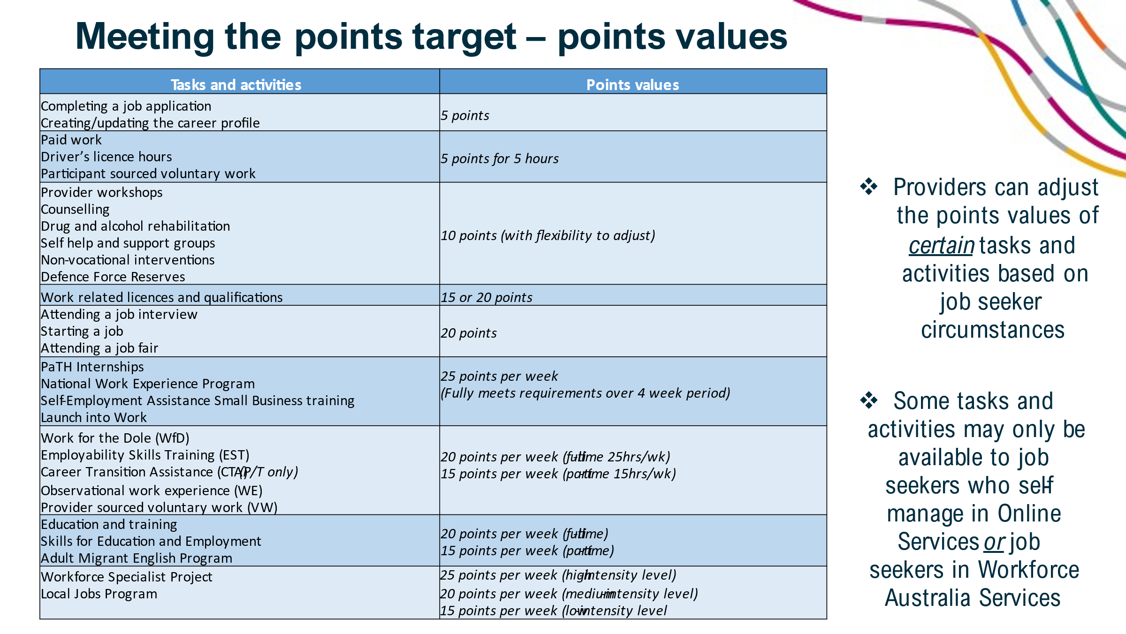

A key feature of PBAS is that job seekers have greater personal responsibility to choose the tasks and activities to meet and manage their mutual obligation requirements.

These tasks and activities include job search, job interviews, commencing a job, paid work, study and training and non-vocational activities as well as participation in departmental employment programs such as Work for the Dole or PaTH Internships.

Key examples are on the screen. Some tasks or activities may only be available to self-managing job seekers in Online Services, or job seekers in Workforce Australia Services.

Generally, job seekers in Workforce Australia Services need additional support and services, so they have a more diverse menu of tasks and activities available to them, including access to non-vocational interventions.

All tasks and activities are assigned a points value, with more intensive activities attracting more points. The points value assigned are based on the level of engagement and commitment required to complete the task or activity and the strength of the link to employment.

We will first look at some of the types of tasks that a job seeker can complete and their points values.

A job seeker can earn *5 points* for completing a job application. The points value attributed to each job application was used as a benchmark to determine the points values for all other tasks and activities by comparing the level of engagement, effort and commitment required to complete the task and activity.

For paid work, driver’s licence hours or participant sourced voluntary work, job seekers will earn *5 points for 5 hours* (rounded up).

* The points value for paid work has been increased from the PBAS trial based on feedback that there should be greater recognition of working. The introduction of a minimum job search requirement in the Workforce Australia model has supported this change and ensures the majority of job seekers are required to continue to look for additional employment whilst on income support.

The points for the following tasks are set at *20 points*. These points values have been increased from the trial to recognise and reward this major step towards gaining paid employment.

* Attending a job interview
  + *Allowing job seekers to report that they attended a job interview recognises the level of engagement often required in preparing for and attending the job interview.*
* Starting a job
  + *Allowing points for starting a job recognises the significance of securing paid employment, even if it is a short-term or casual role.*
* Attending a job fair
  + *This can include face to face and virtual job fairs. Job seekers can only claim points for attending one job fair per year.*

Another key change in the Workforce Australia model is the allocation of points for activities.

* Firstly, activities with a reasonable prospect of a job where the focus of the job seeker should be on fully participating and aiming to land that job, will be allocated 25 points per week of participation. There will be no requirement for them to undertake other tasks to meet their points target.
  + *An example of this would be a PaTH Internship, or National Work Experience Program (NWEP).*
  + *Job seekers undertaking these activities will not be required to complete the minimum job search requirement each reporting period they are undertaking the activity.*
* Then there are activities that have contact hours of up to 25 hours per week and require strong engagement and commitment from the job seeker. These activities will be allocated 20 points per week for full-time participation and 15 points per week for part-time participation, up to 15 hours per week.
  + *An example of this would be Work for the Dole, Employability Skills Training (EST), Education and training and Language, Literacy and Numeracy (LLN) courses.*
  + *Job seekers undertaking these activities will be required to complete other tasks to meet their points target including the minimum job search requirement each reporting period.*
  + *Providers and the DSCC may also adjust the points values for job seekers undertaking LLN courses to reflect the individual’s circumstances.*

Providers can further tailor the points value for certain tasks and activities based on their understanding of the capacity of the individual job seeker. This will be done by applying a type of personal circumstance credit called an Activity Bonus. This is to differentiate between the tailoring of the points target and the tailoring of the points value attached to an activity or task.

For example, most licences are undertaken as half-day to 3-day courses and are set at 15 points on completion. The provider may increase the points value to recognise a course or qualification longer than 3 days, or to reflect a job seeker’s individual circumstances.

Another example is where a job seeker is undertaking counselling sessions multiple times a week over several weeks. The provider may increase the points value by applying an Activity Bonus to recognise the job seeker’s time in attending the sessions including any travel time.

Providers also have the flexibility to add additional tasks that job seekers can participate in to earn points. For example, attendance at a jobs fair.

A full list of the points values for tasks and activities will be included as an attachment to the Workforce Australia Services guidelines.

# Slide 8 – Meeting the points target

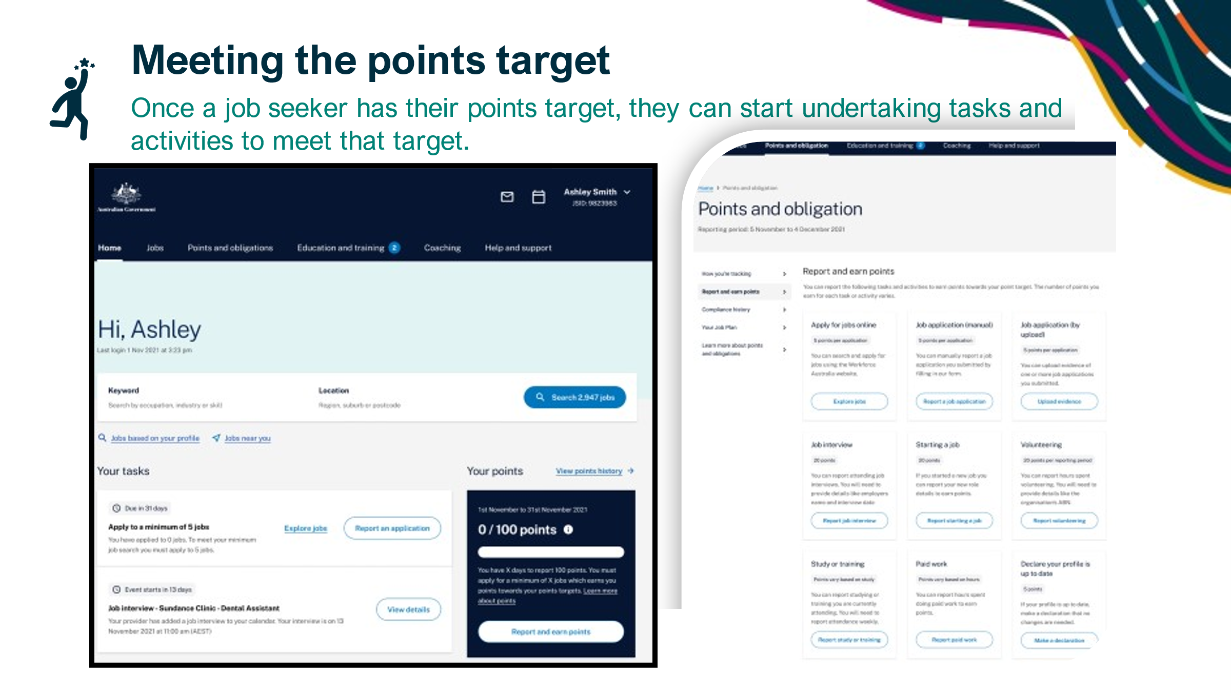

Once a job seeker has their points target, they can start undertaking tasks and activities to meet that target. The tasks and activities will be available from a menu on the job seeker’s homepage.

Job seekers in Workforce Australia Services will be supported by providers to manage their participation and reporting through PBAS.

Providers are expected to identify and promote a diverse range of tasks and activities appropriate for the job seeker to meet their tailored points target and help them on their pathway to employment.

The provider will regularly review the tasks and activities to ensure they continue to be suitable. Providers will support the job seeker to meet their points target every month including assisting the job seeker to report their job search, tasks and activities, where needed.

Self-managing job seekers in Online Services will manage their own participation requirements and will have access to a range of tools and information available on the Workforce Australia website.

They will have support from the DSCC whenever needed to assist them with using PBAS. This includes managing their participation, reporting attendance and discussing the tasks and activities available to the job seeker.

# Slide 9 – Meeting the points target

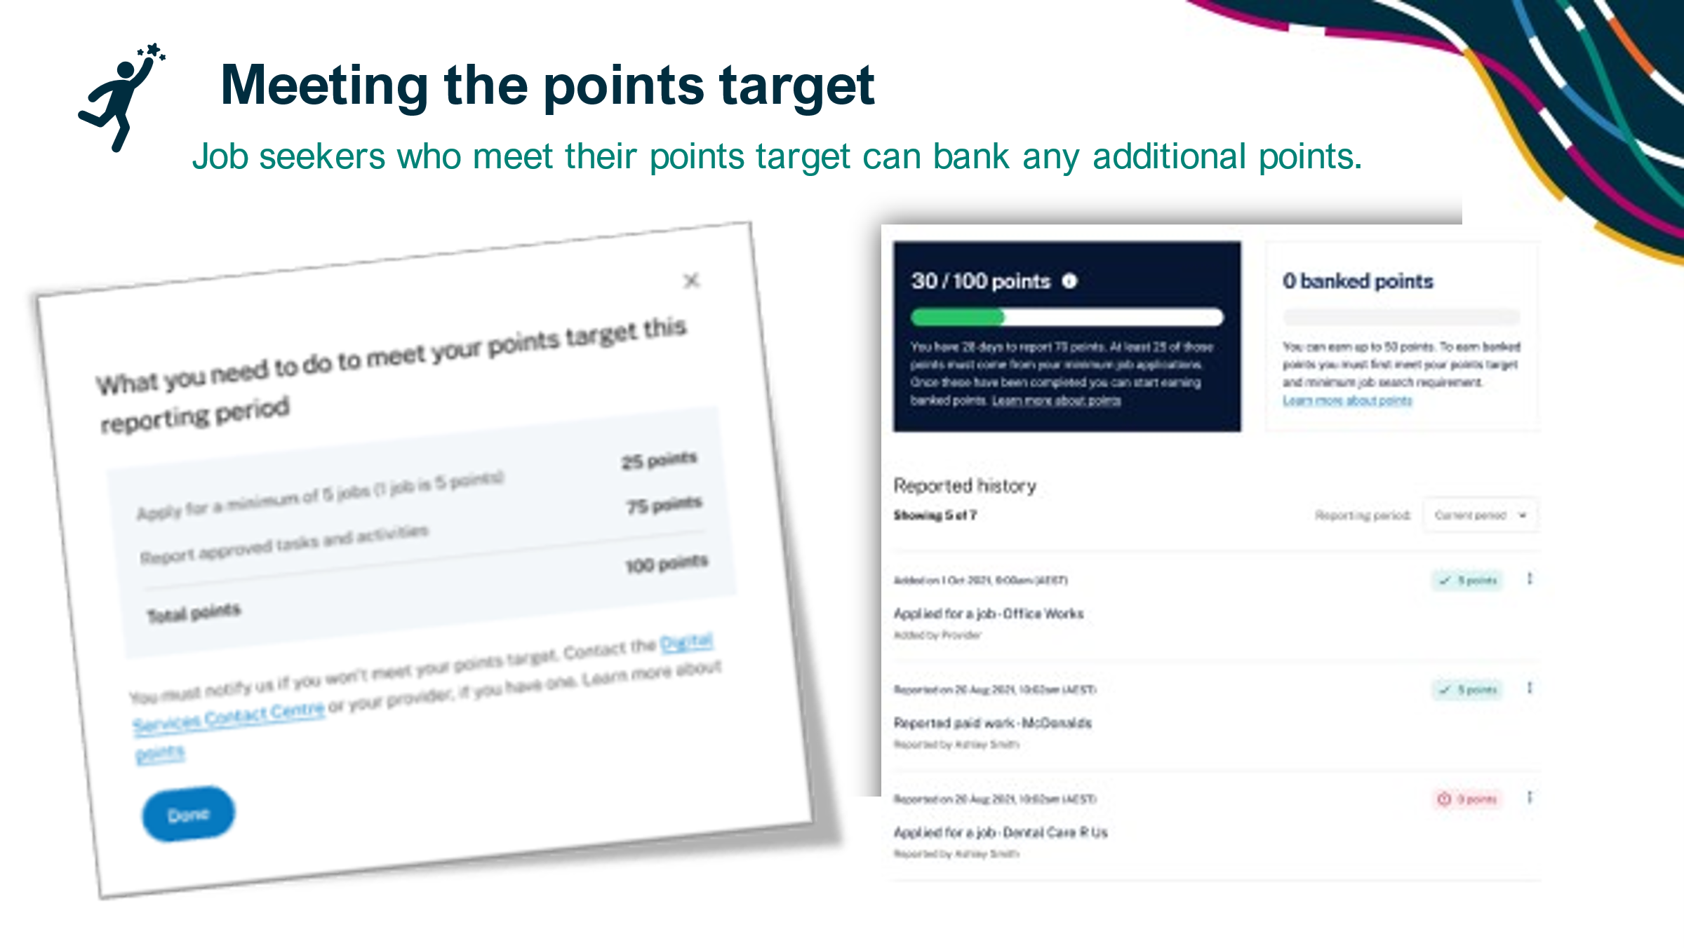

Under PBAS, a job seeker has one month to earn points towards their individual points target.

Job seekers will earn points by reporting the completion of a task by using the Workforce Australia website and/or Workforce Australia app or through support from the provider or the DSCC, as required. Once the job seeker reports the task, the Department’s IT System will automatically allocate the relevant points to the job seeker, to go towards their points target.

Job seekers will be sent reminders about reporting their participation via SMS or email and inbox at 15 calendar days before the end of their points reporting period, and again at 5 calendar days before the end of their points reporting period.

A key change from the trial of PBAS is the allocation of points for activities from upfront credits to the earning of points following the reporting of their attendance at that activity. This was strongly supported during stakeholder feedback.

Points will be awarded following attendance of at least one day, however, job seekers are expected to attend every day scheduled and report that attendance.

There may be circumstances where a job seeker will contact their provider or the DSCC for assistance in reporting the completion of a task or attendance at an activity.

For example, where the job seeker cannot self-manage their own reporting requirements and the provider must do it for them, or in one-off situations where the job seeker has damaged their device or has connectivity issues and cannot report online.

Providers and the DSCC must report these tasks and activities on the job seeker’s behalf by close of business on the day they are advised by the job seeker.

At the end of their reporting period, if a job seeker meets their points target, they can bank any additional points they have received for the next reporting period (up to half of their target). Banking points provides additional flexibility and the principle of banking points was supported by trial providers as it rewards job seekers who do more tasks to get them closer to employment.

# Slide 10 – Examples of meeting the points target

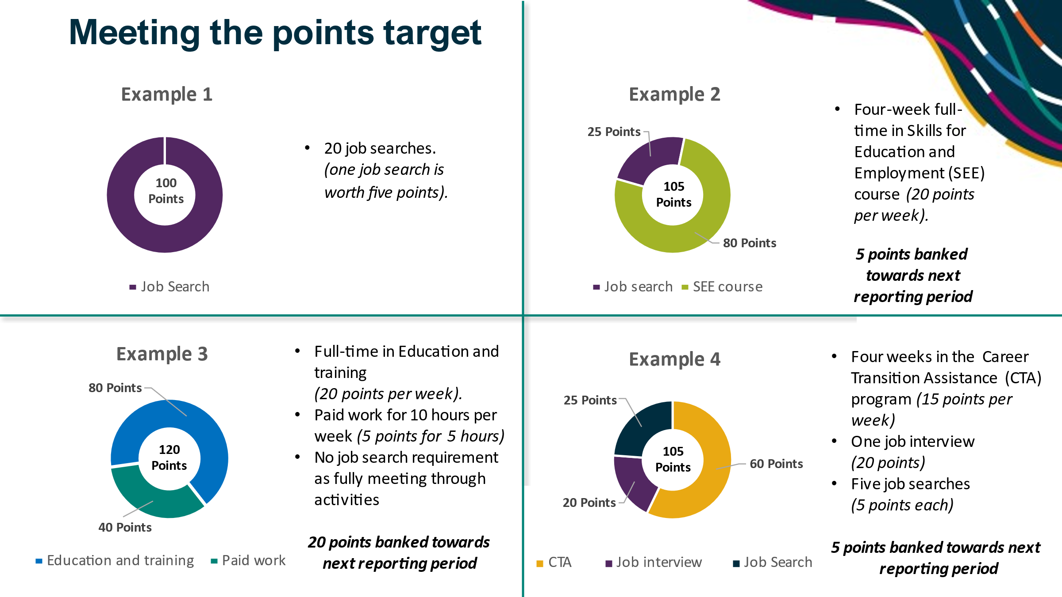

As noted earlier, job seekers can meet their monthly points target in a variety of ways. On the slide, there are some examples of job seekers meeting their monthly points target, in a diverse range of ways.

These examples demonstrate the greater flexibility that the PBAS offers, in how an individual chooses to meet their mutual obligation requirements.

It is important to note that these examples are based on a points target of 100 points and there are no contingency arrangements applied.

Example 1 –

A job seeker can meet their points target through job search alone, by submitting 20 job searches. One job search is worth 5 points.

*100 points = 20 job searches (100 points).*

Example 2 -

This example shows a job seeker meeting their points by submitting 5 job searches and participating full-time in a Skills for Education and Employment course over the four-week reporting period.

*105 points = five job searches (25 points) + four-weeks of full-time participation in SEE (80 points) (5 points can be banked).*

Providers or the DSCC may choose to reduce the minimum job search requirement to zero to reflect the job seeker’s circumstances. In this instance, the job seeker would need to earn 20 points to meet their points target. This could be done by job search, or by completing other tasks, as there is no minimum job search requirement.

Example 3 -

This example shows a job seeker fully meeting their target by undertaking full-time Education and training and working in paid employment for 10 hours each week. Job seekers undertaking a combination of paid work and Education and training, up to 70 hours per fortnight, are not required to complete a job search requirement.

*120 points = Education and training (80 points) + 10 hours per week of paid work (40 points) (20 points can be banked).*

Example 4 -

This example shows a job seeker meeting their points by participating in the Career Transition Assistance program over the 4-week reporting period, attending one job interview and completing five job searches.

*105 points = Career Transition Assistance (60 points) + one job interview (20 points) + five job searches (25 points) (5 points can be banked).*

# Slide 11 – High level overview of activation points

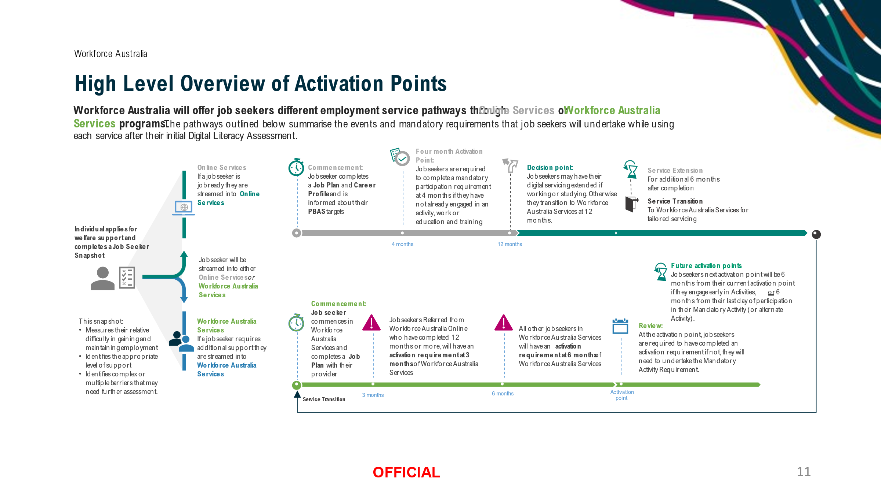

Job seekers are encouraged to participate early in suitable activities, education, or work experience that will support their pathway to employment. Providers are responsible for sourcing appropriate activities and ensuring job seekers are aware of their activation requirement and that they may have a Mandatory Activity Requirement. If a job seeker does not meet their activation requirement by their activation point, they may be required to undertake the mandatory activity (up to 25 hours per week).

Under Workforce Australia, the flexible points-based system is complimented with activation points. These will be earlier and more frequent than under the current model, jobactive, at 4 months for self-managing job seekers in Online Services, and 6 months for job seekers in Workforce Australia Services.

Job seekers who are referred from Online Services after 12 months or more to Workforce Australia Services, will have an activation point at 3 months.

At the activation point, job seekers can meet the activation requirement by undertaking the minimum number of hours required for either:

* one approved activation activity, or
* one or more provider-assessed activation activities (for job seekers in Workforce Australia Services).

This recognises that each job seeker has a unique pathway to employment.

Work for the Dole is the mandatory activity for eligible job seekers in Workforce Australia Services who have not met their activation requirement by the activation point.

Employability Skills Training will be the default mandatory activity for self-managing job seekers in Online Services.

These Mandatory Activity Requirements and the mandatory activity will be included in the job plan as a compulsory activity.

Providers and the DSCC will be able to override the default mandatory activity to select a more appropriate activity for their job seeker, where necessary.

Job seekers in Workforce Australia Services can be placed into an alternate activity instead of the mandatory activity if it is more suitable and meets the needs of the job seeker. An alternate activity is a voluntary activity and cannot be entered into the job seeker’s job plan. The job seeker however would earn points for attendance at the activity which contribute towards their points target. If a job seeker does not complete the alternative activity, they will be placed into the mandatory activity, Work for the Dole.

# Slide 12 – High level overview of Targeted Compliance Framework (TCF)

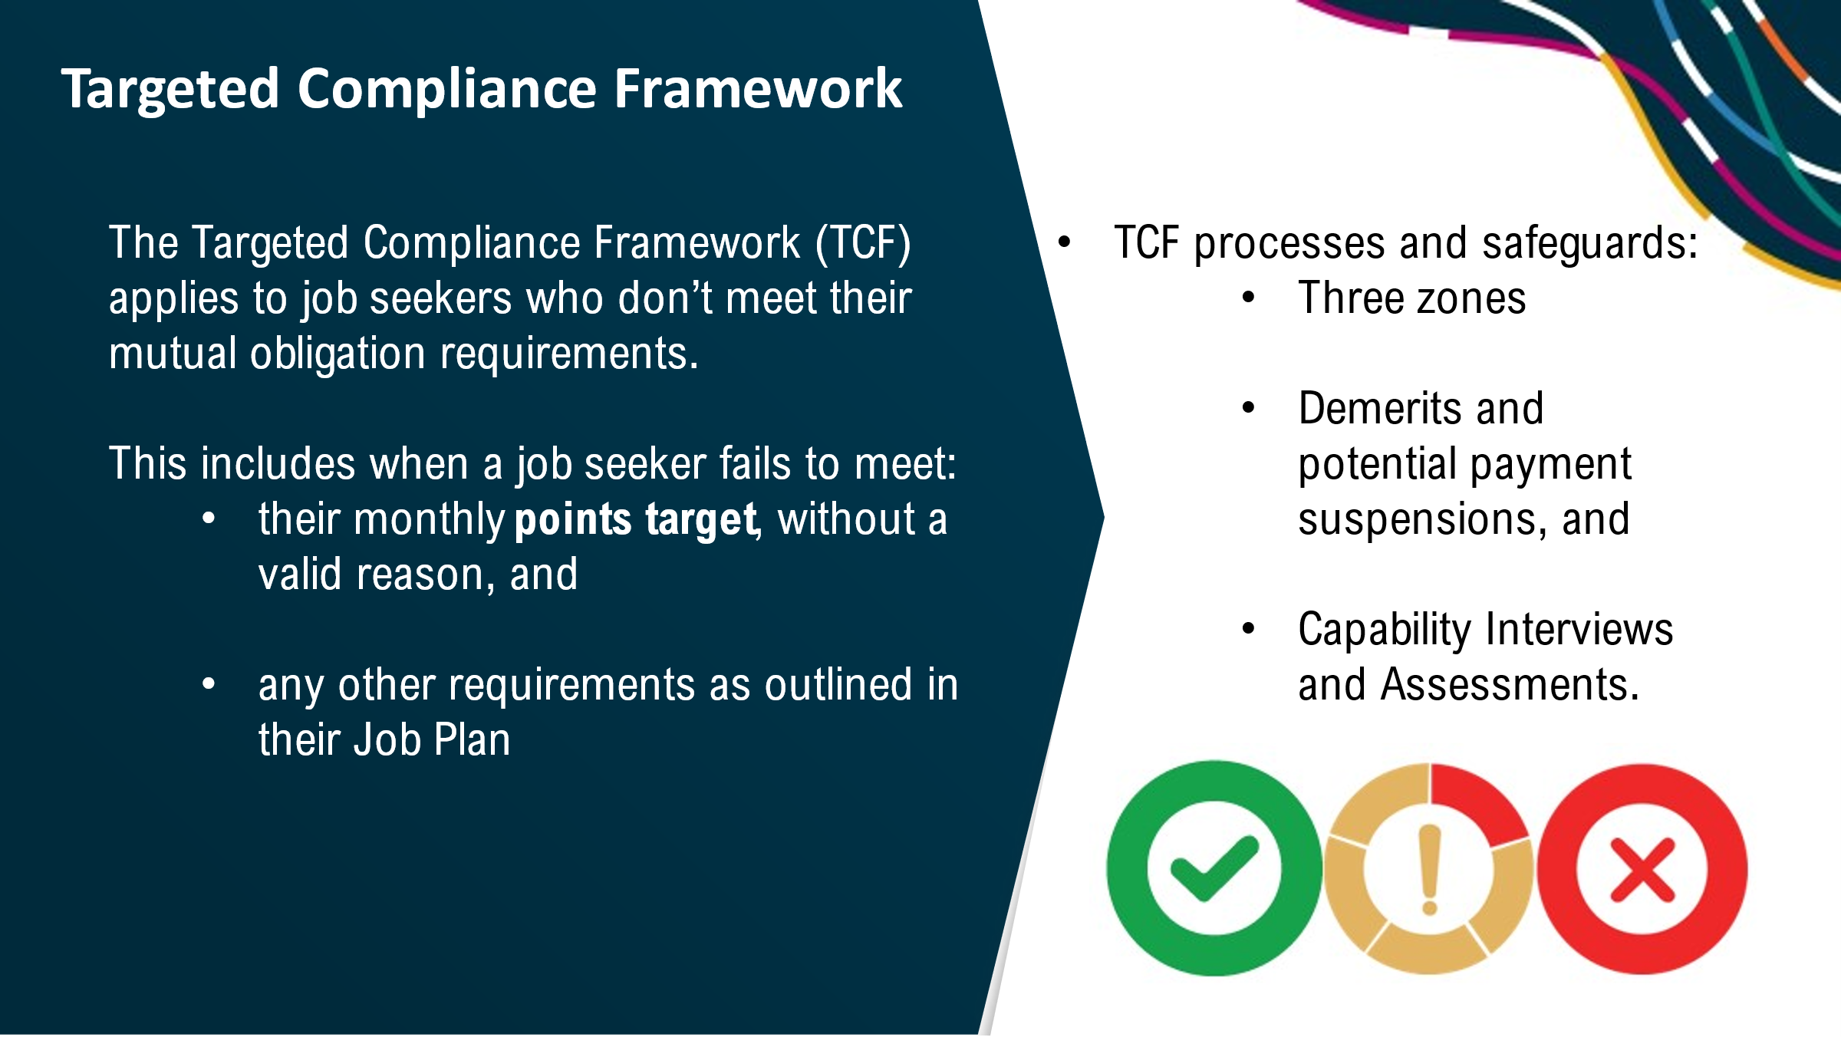

**Targeted Compliance Framework (TCF)**

The TCF is part of the current employment services and existing policy and operations are primarily being carried over to Workforce Australia. Changes made have been to align the TCF with the points-based system and the revised mandatory activation points.

The TCF is designed to encourage job seekers to stay engaged with their mutual obligation requirements and actively look for work.

The TCF comprises three zones (green, warning and penalty zone). This allows job seekers to know how they are tracking and take personal responsibility in meeting their mutual obligation requirements.

Providers play a key role in tailored requirements for job seekers and appropriately applying the TCF where needed. Mandatory provider training on the TCF is part of the suite of training available for the start of Workforce Australia.

The TCF applies to job seekers when they don’t meet their mutual obligation requirements, without a good reason - including meeting their monthly points target.

When job seekers in the green or warning zones do not meet requirements without a good reason they accrue demerits.

Job seekers may also have their payment suspended (that is, their payment is put on hold) if they do not discuss or resolve the non-compliance with their provider within two business days.

If they don’t have a good reason, they must meet a re-engagement requirement to lift their payment suspension.

There are two review points - Capability Interviews (conducted by Providers) and Capability Assessments (conducted by Services Australia) they both serve the same purpose: to make sure the job seeker is capable of meeting their requirements.

Financial penalties are targeted to those who persistently commit mutual obligation and for those who commit a work refusal or unemployment failure. All financial penalties are investigated and applied by Services Australia.

# Slide 13 – Thank you and closing



**Closing**

The department is developing a range of communication and training materials on PBAS that will be available to providers and also the DSCC staff. This will include training modules, IT demonstrations guidelines and factsheets. These materials will be available from May 2022.

That brings us to the end of today’s presentation. Thank you for joining us today.

Are there any questions?